TRY SOMETHING NEW

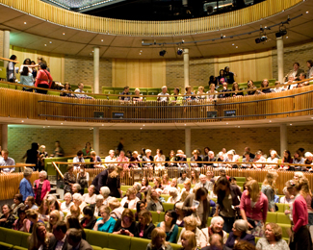

Showcase of Creative Writing Students’ Stage Plays
Reworkings of Classic Plays:
A Doll’s House, The Rover, Antigone, The Glass Menagerie, and The Caucasian Chalk Circle...

TRY SOMETHING NEW

Showcase of Creative Writing Students’ Stage Plays
Reworkings of Classic Plays:
A Doll’s House, The Rover, Antigone, The Glass Menagerie, and The Caucasian Chalk Circle...

TRY SOMETHING NEW

Showcase of Creative Writing Students’ Stage Plays
Reworkings of Classic Plays:
A Doll’s House, The Rover, Antigone, The Glass Menagerie, and The Caucasian Chalk Circle...

TRY SOMETHING NEW

Showcase of Creative Writing Students’ Stage Plays
Reworkings of Classic Plays:
A Doll’s House, The Rover, Antigone, The Glass Menagerie, and The Caucasian Chalk Circle...

