TRY SOMETHING NEW 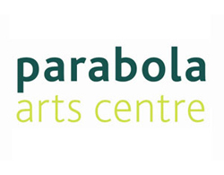

Showcase of Creative Writing Students’ Stage Plays
Reworkings of Classic Plays:
A Doll’s House, The Rover, Antigone, The Glass Menagerie, and The Caucasian Chalk Circle...
Address:
Parabola Road,
Cheltenham,
GL50 3AA
(opposite Cheltenham Ladies’ College)
Book tickets by-
calling the Box Office on +44 (0)1242 707338
or visiting the website at www.parabolaartscentre.co.uk
or taking your chance on the night!

